我嘛會曉講 | 我嘛會曉講 | 我嘛會曉講
阿婆  a-pô | 肉粽  bah-tsàng | 弓蕉  king-tsio
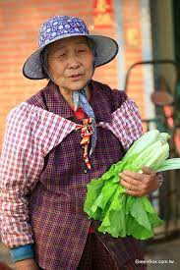 | 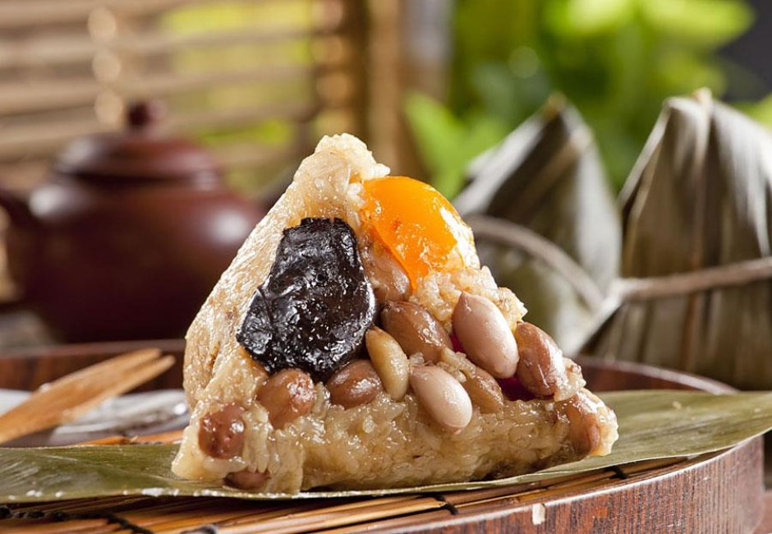 | 